**SQL Constraints (6 types) -----Rules**

In a database table, we can add rules to a column known as **constraints**. These rules control the data that can be stored in a column.

For ex----- if a column has NOT NULL constraint, it means the column cannot store NULL values.

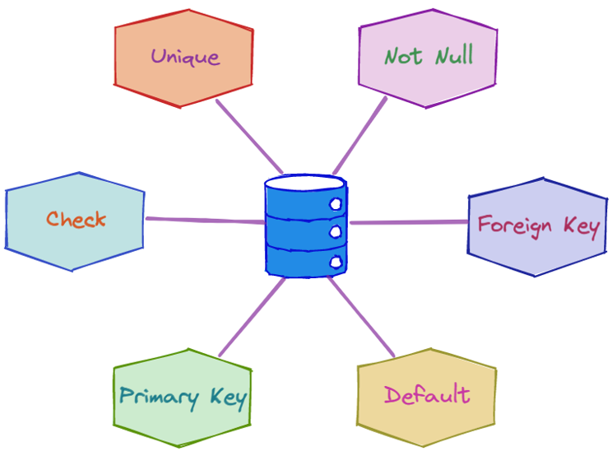

We have different type of constraints here….

======================================

|  |  |
| --- | --- |
| Constraint  =========== | Description  ================== |
| NOT NULL | values cannot be null |
| UNIQUE | values cannot match any older value |
| PRIMARY KEY | used to uniquely identify a row |
| FOREIGN KEY | references a row in another table |
| CHECK | validates condition for new value |
| DEFAULT | set default value if not passed |

**Note:** These constraints are also called integrity constraints.

Examples:

==============

## NOT NULL Constraint

The NOT NULL constraint in a column means that the column cannot store NULL values.

For example,

CREATE TABLE Colleges (

college_id INT NOT NULL,

college_code VARCHAR(20) NOT NULL,

college_name VARCHAR(50)

);

[Run Code](https://www.programiz.com/sql/online-compiler)

Here, the college_id and the college_code columns of the Colleges table won't allow NULL values.

## UNIQUE Constraint

The UNIQUE constraint in a column means that the column must have unique value.

For example,

CREATE TABLE Colleges (

college_id INT NOT NULL UNIQUE,

college_code VARCHAR(20) UNIQUE,

college_name VARCHAR(50)

);

[Run Code](https://www.programiz.com/sql/online-compiler)

Here, the value of the college_code column must be unique. Similarly, the value of college_id must be unique as well as it cannot store NULL values.

## PRIMARY KEY Constraint

The PRIMARY KEY constraint is simply a combination of NOT NULL and UNIQUE constraints. It means that the column value is used to uniquely identify the row.

For example,

CREATE TABLE Colleges (

college_id INT PRIMARY KEY,

college_code VARCHAR(20) NOT NULL,

college_name VARCHAR(50)

);

[Run Code](https://www.programiz.com/sql/online-compiler)

Here, the value of the college_id column is a unique identifier for a row. Similarly, it cannot store NULL value and must be UNIQUE.

## FOREIGN KEY Constraint

The FOREIGN KEY (REFERENCES in some databases) constraint in a column is used to reference a record that exists in another table.

For example,

CREATE TABLE Orders (

order_id INT PRIMARY KEY,

customer_id int REFERENCES Customers(id)

);

[Run Code](https://www.programiz.com/sql/online-compiler)

Here, the value of the college_code column references the row in another table named Customers.

It means that the value of customer_id in the Orders table must be a value from the id column of the Customers table.

- this table doesn't contain foreign keys

CREATE TABLE Customers (

id INTEGER PRIMARY KEY,

name VARCHAR(100),

age INTEGER

);

-- create another table named Products

-- add foreign key to the customer_id column

-- the foreign key references the id column of the Customers table

CREATE TABLE Products (

customer_id INTEGER ,

name VARCHAR(100),

FOREIGN KEY (customer_id)

REFERENCES Customers(id)

);

[Run Code](https://www.programiz.com/sql/online-compiler)

Here, the customer_id column in the Products table references the id column in the Customers table.

## Referencing Columns in Another Table with FOREIGN KEY

The FOREIGN KEY constraint in SQL establishes a relationship between two tables by linking columns in one table to those in another. For example,

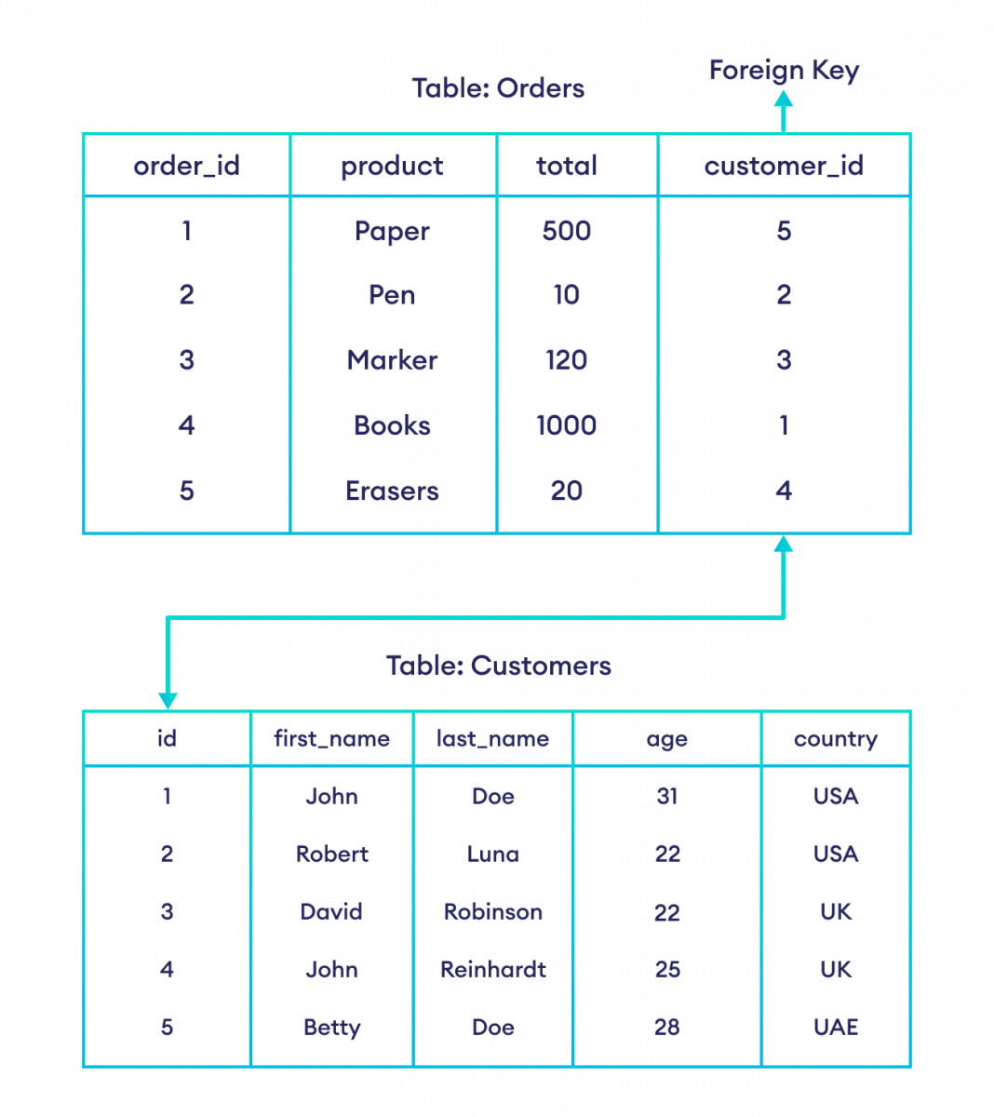

## CHECK Constraint

The CHECK constraint checks the condition before allowing values in a table.

For example,

CREATE TABLE Orders (

order_id INT PRIMARY KEY,

amount int CHECK (amount >= 100)

);

[Run Code](https://www.programiz.com/sql/online-compiler)

Here, the value of the amount column must be **greater than or equal to 100**. If not, the SQL statement results in an error.

## DEFAULT Constraint

The DEFAULT constraint is used to set the default value if we try to store NULL in a column.

For example,

CREATE TABLE College (

college_id INT PRIMARY KEY,

college_code VARCHAR(20),

college_country VARCHAR(20) DEFAULT 'US'

);

[Run Code](https://www.programiz.com/sql/online-compiler)

Here, the default value of the college_country column is **US**.

If we try to store the NULL value in the college_country column, its value will be **US**.

|  |  |  |  |  |  |
| --- | --- | --- | --- | --- | --- |
| **id** | **First_name** | **Last_name** | **age** | **country** |  |
|  |  |  |  |  |  |
|  |  |  |  |  |  |
|  |  |  |  |  |  |
|  |  |  |  |  |  |
|  |  |  |  |  |  |
|  |  |  |  |  |  |
|  |  |  |  |  |  |